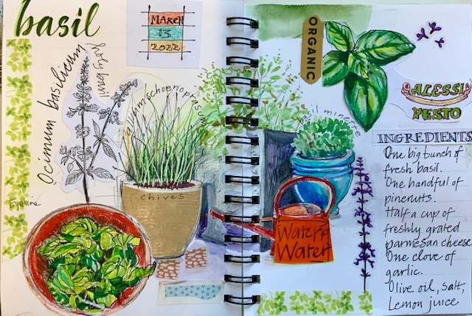Page from Di’s journal

A Kitchen Garden Journal: Herbs
13 March 2022, 10am–3pm
online live via Zoom

Description
Join Olive and Di and rekindle your creative mojo, letting go of perfection, and making a journal of your observations of a few familiar herbs from an imaginary kitchen garden. Record the day and the produce of a bountiful season: pots of basil, chives and thyme, studies of your freshly picked herbs, and/or drawing subjects from supplied photo references on your computer screen, iPad or tablet.

Who is it for?
Anyone attracted to the idea of journalling – putting imagery and lettering together in a sketchbook, exploring materials, recording memories, growing, cooking and eating food. No previous drawing experience is required; you will only need the desire to experiment with pencil, paint and paper.

Before the class
Direct observation from ‘life’ is the best way to start. It’s a good idea to make a few thumbnail sketches of some produce, including herbs, either growing in your own garden or purchased from farmers’ markets, such as the Hmong community vegie stalls at Salamanca, which are so visually stimulating. A site visit can reveal all kinds of surprising additional material and ideas that speak to you. You could set up a ‘still-life’ arrangement at home in preparation for the workshop. Your themes might include ‘herbalism’, ‘cultivation’, ‘history of’ or ‘culinary’ – anything!
Olive will provide detailed instructions in advance for students to make a small pamphlet-style journal to be used in class.

Students will learn
PART 1 (draw along with Di)
We’ll start the class with drawings of our selected subject matter and experiment with a variety of approaches:
- a continuous line sketch to warm up and to exercise eye/hand coordination
- a more controlled pencil contour drawing emphasising observation, deciding on a focal point; introducing shadow shapes, tones and deciding what to leave out
- exploring line and light wash, layering and mixing colour with a range of materials
- introducing additional elements on the page (date stamps, text blocks, borders etc.
PART 2 (words of wisdom from Olive)
We will also discuss the composition of the page and layout, and pay attention to appropriate lettering to accompany the sketching.

